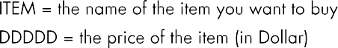

6000 3
Phone-case 1486
Candybar 863
Sunglasses 5529
2100 3
Camera 69555
TV 76439
iPhone 90000

I can afford Phone-case I can afford Candybar
I can't afford Sunglasses 3651
I can't afford Camera I can't afford TV
I can't afford iPhone I need more Dollar!

char name[MAX][LEN]; int price[MAX] afford[MAX]

for(i=0;i<items;i++)

11 250 33

